Ambulatory Multiple Myeloma Bispecific Antibody Workflow
Table of Contents
Patient Eligibility 1
Logistics 2
Admission for CRS/Neurotoxicity 4
REMS Workflow 5
Roles and Responsibilities 5
Contact Information 6
Appendix I: Teclistamab Schedule Example 7
Appendix II: Talquetamab Schedule Example (Biweekly) 7
Appendix: III: Elranatamab Schedule Example 8
Appendix: IV: Linvoseltamab Schedule Example 9
Appendix V: Teclistamab + Talquetamab 10
Appendix VI: Provider Coverage 10

Patient Eligibility
Select patients may be eligible for outpatient bispecific antibody step-up dosing.
Patients that may be possible candidates include:
- Age ≥ 18
- ECOG performance score < 1
- No active, uncontrolled infection
- No active, symptomatic heart disease, uncontrolled coronary artery disease or arrhythmias and has an LVEF ≥50%
- FEV1 and DLCOcHB ≥75%
- Patient does not have a documented history of cirrhosis or fibrosis
- Patient’s total bilirubin is <2mg/dL, or if total bilirubin is >2.0mg/dL, the abnormal result is due to Gilbert’s syndrome or hemolysis
- Patient’s serum creatinine is ≤ 2.0mg/dL and the patient’s eGFR is ≥30 mL/min/1.73m²
- Patient must not be pregnant
- Patients own a cell phone
- Patient has a 24-hour 7 day/week caregiver for the duration of step-up dosing schedule (10 days)
- Patient has a caregiver that will transport them daily to appointments and meet with the clinical team
  - Patient may not drive 48 hours after step-up dose 1, step-up dose 2, and the first full dose
- Patient has access to clean safe housing within a 60-minute drive of Dana-Farber Cancer Institute

Patient that may not be possible candidates include:
- Any prior Grade 3 or higher CRS or neurotoxicity
- Prior HLH
- M-spike > 4 g/dL or high tumor burden
- Active CNS disease

Logistics
- Appointments
  - Prior to C1D1 visits
    - Consenting visit with MM MD
    - Pharmacy Teach visit
    - ONN/Research Teach Visit
  - Patients must have C2D1 scheduled by the end of the SUD to ensure appropriate transition of care
  - Lab appointments (Y2), IEC APP visits (Y8), infusion visits (Y7), and infusion nurse follow up visits (Y7) will be scheduled by Andrew or Grace. Pharmacy and ONN teach visits will be scheduled by myeloma back-office schedulers, who will also relay all appointment information.
  - After step-up doses are completed, treatment doses can be scheduled by Y7 or MM back-office schedulers. This must be scheduled by the last step-up dose.
  - Lab appointments must be made for daily for the duration of step-up dosing days
    - CMP, CBC/diff, LFTs, uric acid, phosphorous, magnesium, CRP, LDH, IL-6, ferritin, fibrinogen , SPEP/IFE, SFLC, B2M
    - Infectious Disease work up – CMV PCR, Hepatitis Panel, Viral Respiratory Panel

Labs | Treatment Days | Non-Treatment Days
CBC and differential | Daily | Daily
Comprehensive metabolic panel | Daily | Daily
SPEP panel with immunofixation | D1 Only
Free light chains, serum | D1 Only
C-reactive protein, high sensitivity | Daily | Daily
Ferritin | Daily | Daily
Uric Acid | Daily | Daily
Beta-2 microglobulin, blood | D1 Only
Phosphorus | Daily | Daily
Magnesium | Daily | Daily
LDH | Daily | Daily
Interleukin 6 | Daily | Daily
BWH Ambulatory Respiratory Virus Testing Panel | D1 Only
Hepatitis Panel | D1 Only
Cytomegalovirus (CMV) PCR, blood | D1 Only

  - Clinic appointments Provider Appointments Will be On Y8 w/ APPs
    - Provider visits must be daily unless other wise described (Monday through Friday)
      - Appointments are typically in the morning (exceptions are linvoseltamab)
      - Patients will be scheduled with providers on Y8 with the Cell Therapies APP’s
      - Review labs + patient assessment as per usual
      - Assess CRS/Neurotoxicity
        - S/sx of CRS: fevers (≥ 100.4°F), difficulty breathing, chills, rapid HR, low BP, dizziness/light-headedness, feeling anxious, confusion/restlessness, headaches
        - S/sx of neurotoxicity: headache, jerking movements, rigid muscles, feeling restless, numbness/tingling, confusion, trouble speaking, muscle spasms, tremor, changes in handwriting, problem walking, hearing loss, muscle weakness in your body or face, double vision, burning/throbbing/stabbing pains
        - Assess and document ICE score
      - Assess any needs for fluids/blood products
      - Wallet card must be filled out on by first full dose.
      - Monitoring supplies must be provided (blood pressure monitor, SPO₂ monitor, and thermometer)
  - Y7 appointments
    - All treatment appointments must be made on Y7
      - It should be noted that any delay in treatment means that appointments may need to be changed to accommodate new dosing schedule
    - Appointments are typically in the morning (except for linvoseltamab)
    - Ensure patient has working supplies and outpatient workbook
    - Precautions
      - Step up doses should NOT be scheduled on Friday due to limited staff on weekends
      - Step up doses should NOT be scheduled before holidays
  - RN appointments
    - Daily Telephone Call at 5PM for 1 hour
- Outpatient prescriptions
  - Consider sending patient home with prescriptions for acetaminophen (650 – 975mg), diphenhydramine (25- 50mg), and dexamethasone (8 – 12mg) per provider discretion.

Admission for CRS/Neurotoxicity
- If ANY deviation from baseline on PM check in will re-evaluate in clinic
  - Grade 1 CRS before 3pm: re-evaluate in infusion (add on appt),
    - If an admission is needed, consider a direct admission. If there is no bed by 5PM, patient will be transferred to the ED.
    - Discuss w/ primary attending or back up if tocilizumab/steroids will be given prior to transfer
      - Will need STAT order by 4pm, infusion needs to end by 5pm so can facilitate transfer to BWH
      - Patient needs to transfer at 5pm to ED or their admission bed
  - Any Grade CRS after 3pm: Patient will be directed to the ED
  - Grade 2 CRS or higher in clinic, will be transferred to the ED via ACLS, do NOT delay transfer to give tocilizumab tocilizumab should be admin by ED for G2+
  - Grade 2 at home, Direct to ED
- CRS Work Up/Interventions that can be done in clinic:
  - Obtain VS, consider sepsis as ddx
  - Labs: CRS: CRP, IL-6; Sepsis work up: bldcx/ ua/lactate/ucx/cxr, procalcitonin; HLH: ferritin, coags w/ fibrinogen, lipid panel (triglycerides) and sIL-2
  - If F+N, order above work up and start Ceftazidime (avoid Cefepime as this can cause AMS, especially in elderly and cloud the neurotoxicity picture).
  - procalcitonin (if >7, panscan and broaden abx, HIGH mortality!)
v. Monitor daily ferritin, coags w/ fibrinogen
  - Tocilizumab 8mg/kg can be ordered stat and administered in clinic at 4pm if no direct bed is available (needs to be before 4pm to accommodate a 5pm transfer to the ED). ONLY for G1 CRS in clinic.
  - If grade 2 or higher; intervene as appropriate until ACLE transfer arrives for ED transfer

REMS Workflow
All multiple myeloma standard of care bispecifics have risk evaluation and mitigation strategy (REMS) programs in place. Specifically, these agents must abide by elements of safe use (ETASU) A) Certification or specialized training of HCPs who prescribe the drug, B) Certification of pharmacies or other dispensers of the drug, and C) dispensing/administration of drug in limited settings.
To meet A, all providers (who are signing orders) must be REMS certified. To meet B, all pharmacists must be trained and be able to verify prescribers via the REMS portal. Finally, to meet C, treating facilities must enroll into the REMS program. Additionally, patients must be provided with a wallet card and medication guide upon receiving the first step up dose. Additional information can be found on the respective agent’s website:
Teclistamab/Talquetamab: https://www.tec-talrems.com/#Main
Elranatamab: https://elrexfiorems.com/#Main
Linvoseltamab: https://www.lynozyficrems.com/#Main

Roles and Responsibilities
- Clinical Assistants – handout/clean/maintain supplies, double height and weight for C1D1
- Clinic Coordinators/Practice Director/Program Administrator
  - Schedule: New Chemo, BITE, Phone Call
- Clinical Schedulers/Protocol Schedulers
  - MD consenting visit (prior to C1D1)
  - Pharmacy Teach Visit (Prior to C1D1), ONN/Research Nurse Teach Visit (prior to C1D1)
  - For C2 Labs, Provider Visits, infusion visits
- Oncology Nurse Navigator/Research Nurse
  - Teach on BOSS workbook, medical devices
  - Transition of care to local (or primary MM team)
  - Document teaching and additional notes
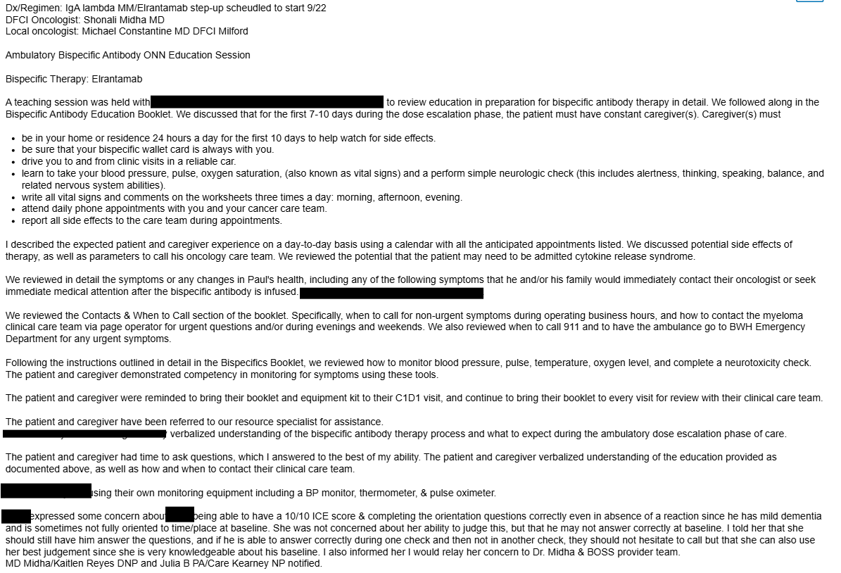
- Clinical Pharmacists
  - Teach on bispecific/trispecific, tocilizumab, supportive care
  - Send supportive care medications
  - Documentation of caregiver, adverse effects, supportive care medications, appointments, clinically significant interactions/medications that may affect CRS/ICANS
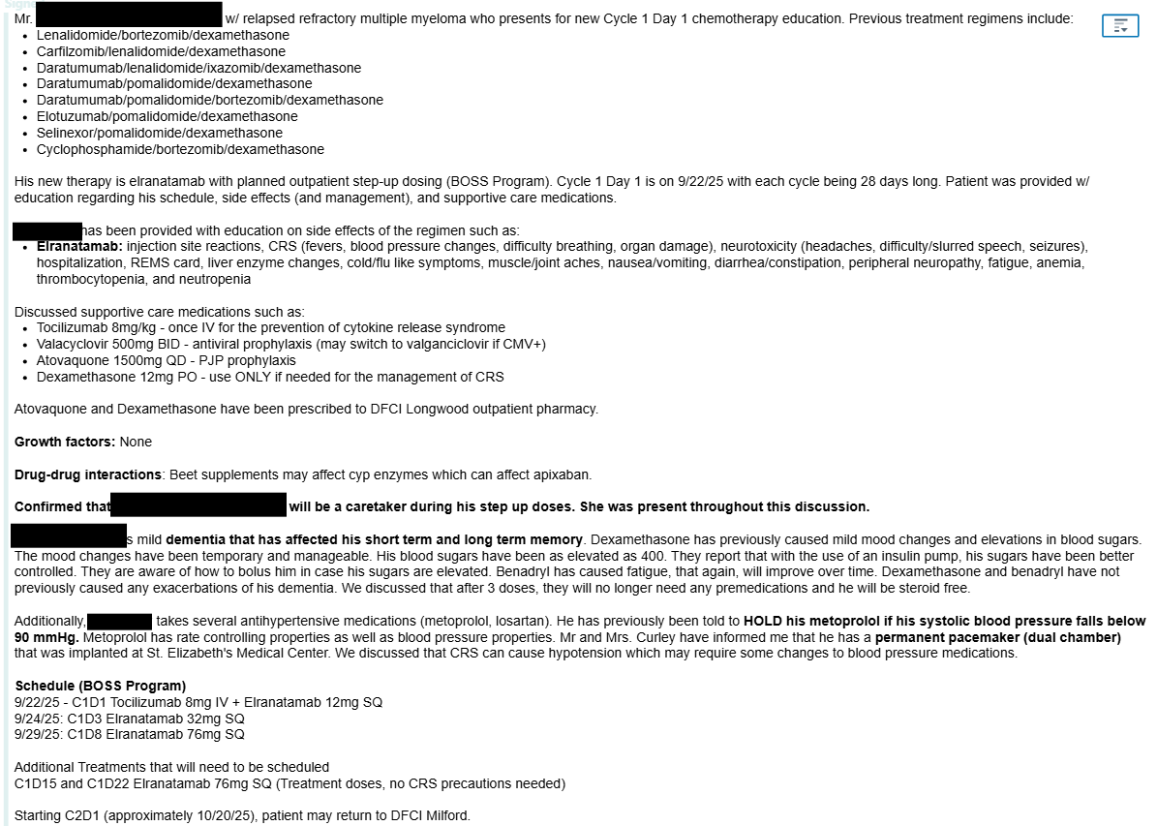
- Infusion Nurse – assess patient, treatment, evening triage phone call
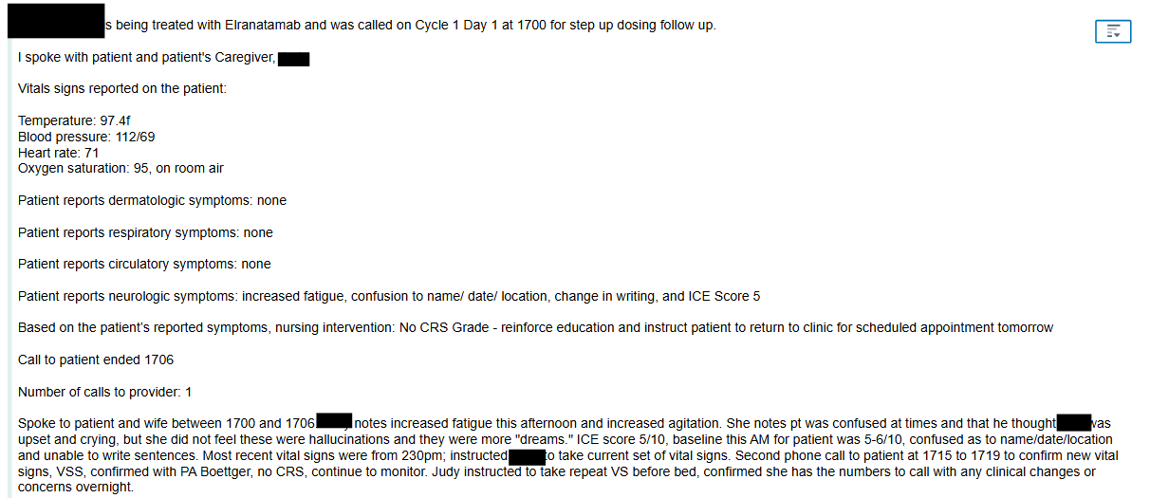
- APPs – patient assessment, clear for treatment
- MDs – patient evaluation for BOSS program, consent, assessment, clear for treatment

Contact Information
MDs:
APPs:
ONNs:
Y7/Y8:
Pharmacist:

Appendix I: Teclistamab Schedule Example
Cycle | Day | Labs | Provider Appointment | Infusion Appointment | Nursing  Follow Up
C1 Day 1 | Monday |  |  | SUD 1 (0.03mg/kg)
C1 Day 2 | Tuesday
C1 Day 3 | Wednesday |  |  | SUD 2 (0.6mg/kg)†
C1 Day 4 | Thursday |  |  | SUD 2 (0.6mg/kg)†
C1 Day 5 | Friday
C1 Day 6 | Saturday
C1 Day 7 | Sunday
C1 Day 8 | Monday |  |  | First Full Dose (1.5mg/kg)
C1 Day 9 | Tuesday
C1 Day 10 | Wednesday
†Step-up dose 2 can be given on Wednesday OR Thursday depending on clinic availability.
- SUD for teclistamab are on Cycle 1 Day 1, 3, and 8
- SUD 2 can be administered 2 – 7 days after SUD 1
- SUD 3 can be administered 2 – 7 days after SUD 2
- We will be aiming for Day 1, Day 3 or 4, and then Day 8
- Cycle 2 Day 1 should be 1 week after C1D8

Appendix II: Talquetamab Schedule Example (Biweekly)
Cycle | Day | Labs | Provider Appointment | Infusion Appointment | Nursing  Follow Up
C1 Day 1 | Monday |  |  | SUD 1 (0.01mg/kg)
C1 Day 2 | Tuesday
C1 Day 3 | Wednesday |  |  | SUD 2 (0.06mg/kg)†
C1 Day 4 | Thursday |  |  | SUD 2 (0.06mg/kg)†
C1 Day 5 | Friday
C1 Day 6 | Saturday
C1 Day 7 | Sunday
C1 Day 8 | Monday |  |  | SUD 3 (0.4mg/kg)‡
C1 Day 9 | Tuesday
C1 Day 10 | Wednesday |  |  | First Full Dose (0.8mg/kg)‡
C1 Day 11 | Thursday |  |  | First Full Dose (0.8mg/kg)‡
C1 Day 12 | Friday
†Step-up dose 2 can be given on Wednesday OR Thursday depending on clinic availability.
‡Patients may be transitioned to every other week dosing schedule depending on provider discretion
- SUD for talquetamab are on Cycle 1 Day 1, 3, 8, and day 10
- SUD 2 can be administered 2 – 7 days after SUD 1
- SUD 3 can be administered 2 – 7 days after SUD 2
- SUD 4 can be administered 2 – 7 days after SUD 3
- We will be aiming for Day 1, Day 3 or 4, Day 8, and Day 10 or 11
- Cycle 2 Day 1 should be 1 week after C1D10

Appendix: III: Elranatamab Schedule Example
Cycle | Day | Labs | Provider Appointment | Infusion Appointment | Nursing  Follow Up
C1 Day 1 | Monday |  |  | SUD 1 (12mg)
C1 Day 2 | Tuesday
C1 Day 3 | Wednesday |  |  | SUD 2 (32mg)‡
C1 Day 4 | Thursday |  |  | SUD 2 (32mg)‡
C1 Day 5 | Friday
C1 Day 6 | Saturday
C1 Day 7 | Sunday
C1 Day 8 | Monday |  |  | First Full Dose (76mg)
C1 Day 9 | Tuesday
†Step-up dose 2 can be given on Wednesday OR Thursday depending on clinic availability.
- SUD are Cycle 1 Day 1, 3, and 8
- The remainder of the cycle, Day 15 and 22 are not SUD and Day 15 should be scheduled with MM team
- SUD 2 can be administered on 2 – 14 days after SUD 1
- SUD 3 can be administered 2 – 14 days after SUD 2
- We will be aiming for Day 1, Day 3 or 4, and Day 8

Appendix: IV: Linvoseltamab Schedule Example
Cycle | Day | Labs | Provider Appointment | Infusion Appointment | Nursing  Follow Up
C1 Day 1 | Monday |  |  | SUD (5mg)
C1 Day 2 | Tuesday
C1 Day 3 | Wednesday
C1 Day 4 | Thursday
C1 Day 5 | Friday
C1 Day 6 | Saturday
C1 Day 7 | Sunday
C1 Day 8 | Monday |  |  | SUD (25mg)
C1 Day 9 | Tuesday
C1 Day 10 | Wednesday
C1 Day 11 | Thursday
C1 Day 12 | Friday
C1 Day 13 | Saturday
C1 Day 14 | Sunday
C1 Day 15 | Monday |  |  | First Dose (200mg)
C1 Day 16 | Tuesday
- SUD for linvoseltamab are Cycle 1 Days 1, 8, 15
- SUD 2 can be administered 7 – 14 days after SUD 1
- SUD 3 can be administered 7 – 14 days after SUD 2
- Cycle 2 day 1 should be 1 week after C1D15
- Linvoseltamab has a unique schedule for the BOSS program
  - Provider visit and labs prior to 1PM
  - Plan is to have patients in infusion chair at approximately 1PM for treatment (premeds/tocilizumab + linvoseltamab = 4 hours)
  - Day 2 and Day 9 Only: Provider visit should be between 7:30 and 8:30AM with infusion nursing visit at 5PM

Appendix V: Teclistamab + Talquetamab
Cycle | Day | Labs | Provider Appointment | Infusion Appointment | Nursing  Follow Up
C1 Day 1 | Monday |  |  | SUD 1
C1 Day 2 | Tuesday
C1 Day 3 | Wednesday |  |  | SUD 2
C1 Day 4 | Thursday
C1 Day 5 | Friday
C1 Day 6 | Saturday
C1 Day 7 | Sunday
C1 Day 8 | Monday |  |  | SUD 3
C1 Day 9 | Tuesday
C1 Day 10 | Wednesday |  |  | First Full Dose
C1 Day 11 | Thursday
C1 Day 12 | Friday
- This is complicated
- SUD for tec+tal are Cycle 1 Day 1, 3, 8 and 10
- Please contact primary attending or Shahrier for deviations in SUD due to it depending on which drug we deviated on
  - If both follow this schedule
    - SUD 2 can be administered 2 – 7 days after SUD 1
    - SUD 3 can be administered 2 – 7 days after SUD 2
    - SUD 4 can be administered 2 – 7 days after SUD 3
- We will be aiming for Day 1, Day 3 or 4, Day 8, and Day 10 or 11
- Cycle 2 Day 1 should be 1 week after C1D10

Appendix VI: Provider Coverage
Date | Primary | Back Up 1 | Back Up 2
Monday | Primary MD/APP
Tuesday | Primary MD/APP
Wednesday | Primary MD/APP
Thursday | Primary MD/APP
Friday | Primary MD/APP
Saturday
Sunday

